

SIMATS ENGINEERING
Saveetha Institute of Medical and Technical Sciences Chennai- 602105
Student Name: Prena M Reg. No.:192524056
Course Code: UBA5312 Slot: A
Course Name: PROBABILISTIC METHODS &LINEAR ALGEBRA
Course Faculty: MS. M. V. Abigail

Project Title: Assessing the Risk of Online Payment Fraud Using Conditional Probability Analysis
Module Photographs:
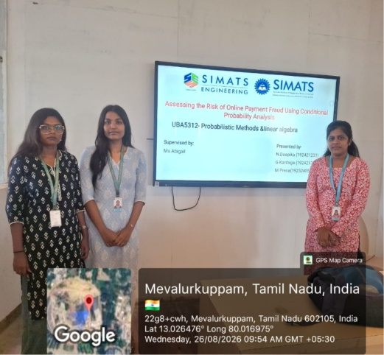
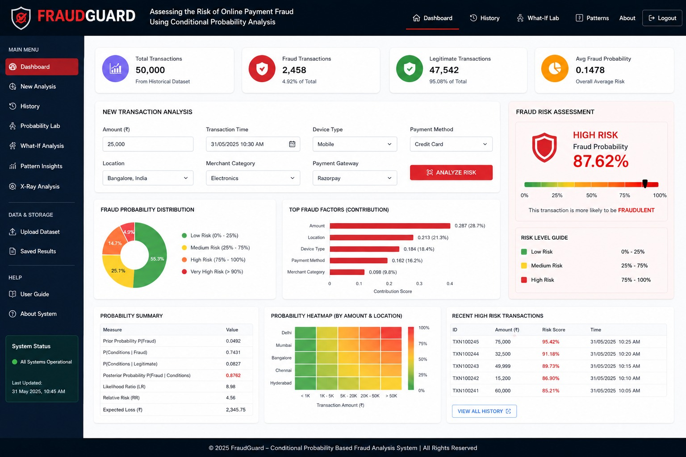
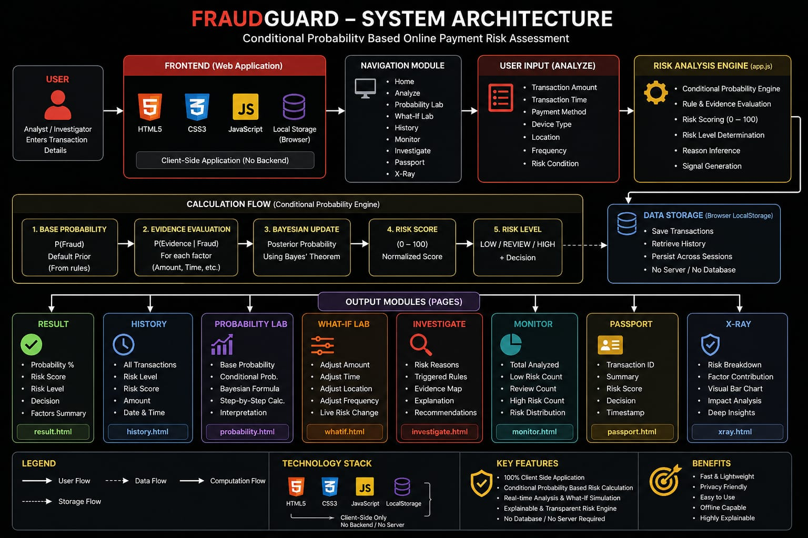

Project Description:
Online payment systems such as UPI, credit cards, and online banking are widely used for daily transactions. However, the increasing use of digital payments has also increased the risk of online payment fraud. This project aims to assess the risk of fraud using the concept of conditional probability. The project considers different factors such as transaction amount, transaction location, transaction time, device used, and previous transaction history. Conditional probability is used to calculate the probability of a transaction being fraudulent when a particular suspicious condition is present. For example, the probability of fraud can be calculated when a transaction is made from an unusual location or when an unusually large amount is transferred. By analyzing these conditions, the project helps identify transactions that have a higher risk of fraud. The main objective of this project is to demonstrate how conditional probability can be applied to a real-world problem and how mathematical analysis can help in identifying and assessing the risk of online payment fraud.

Student Signature Guide Signature

